 | 35 Bforartists Addons
Table of content
Bforartists Addons 1
Default Addons 1
Activated Addons: 1
Official 1
Community 2
Included Addons 2
Import-Export: Bforartists Default Asset Library 3
Mesh: Mesh Tools – Bforartists version 3
Mesh: Smart Delete bfa 3
Paint: Bforartists Brush Panel 3
User Interface: Important Hotkeys BFA 3
User Interface: Toolbar Settings Bforartists 4
Utility: X Ray Weight Paint 4
View: 3D View Reset 4

Bforartists Addons

Bforartists comes with default and included addons to help improve the user experience. Some of these can be activated by the user and saved in the preferences for daily use. Many addons are shipped which include specific user experience improvements. Feel free to activate and use when necessary.

Default Addons
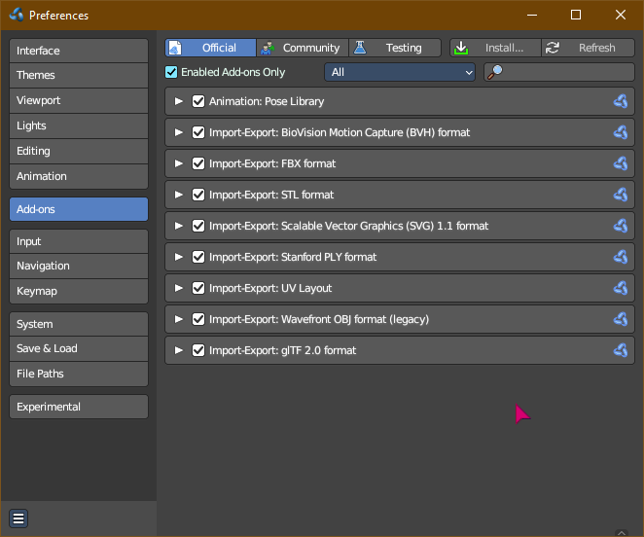
These addons are turned on by default and shiped with Bforartists. Most come directly from the Blender repository. These addons are split into official and community addons.

Activated Addons:

Official
- Animation: Pose Library
- Impot-Export: BioVision Motion Capture (BVH) format
- Import-Export: FBX format
- Import-Export: STL format
- Import-Export: Scalable Vector Graphics (SVG) 1.1 format
- Import-Export: Stanford PLY format
- Import-Export: UV Layout
- Import-Export: Wavvefront OBJ format (legacy)
- Import-Export: glTF 2.0 format

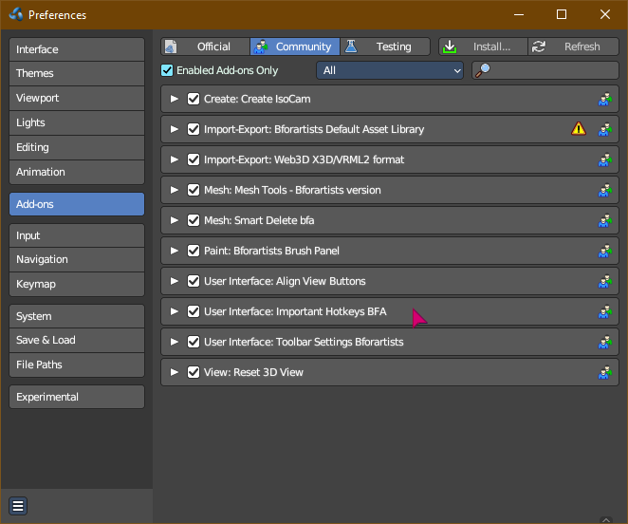
Community
- Create: Create IsoCam
- Import-Export: Bforartists Default Asset Library
- Import-Export: Web3d X3D/VRML2 format
- Mesh: Mesh Tools – Bforartists version
- Mesh: Smart Delete bfa
- User Interface: Align View Buttons
- User Interface: Important Hotkeys BFA
- User Interface: Toolbar Settings Bforartists
- View: 3D View Reset
Note
To activate/deactivate an addon, go to Edit – Preferences – Addons tab – and untick any activated addons.
If you’d like to keep your addons for future use, you can either save the preferences, or activate them on demand per workspace in workspace settings in the property shelf.

Included Addons

Bforartists has included custom addons to improve the user experience. Most are activated by default, some are optional.
- Import-Export: Bforartists Default Asset Library
- Mesh: Mesh Tools – Bforartists version
- Mesh: Smart Delete bfa
- Paint: Bforartists Brush Panel
- User Interface: Important Hotkeys BFA
- User Interface: Toolbar Settings Bforartists
- Utility: X Ray Weight Paint
- View: 3D View Reset

Import-Export: Bforartists Default Asset Library
This addon is activated by default. This includes a default asset library shipped with Bforartists. To know more about what this library includes and how to access it, refer to chapter 28.1 Asset Browser – Default Asset library

Mesh: Mesh Tools – Bforartists version
This addon is activated by default. This addon is a default Blender addon that has been modified to work with Bforartists in a better integrated way.

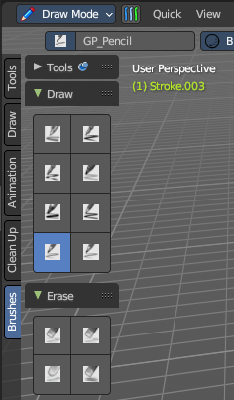
Mesh: Smart Delete bfa
This addon is activated by default. This addon improves the user experience of deleting geometry, so that you can save a few clicks every time you want to remove geometry. Now it detects what you have selected and removes it in a predictable way. To use it, press DEL on selected geometry.
This addon is thanks to Reiner.

Paint: Bforartists Brush Panel
This addon is optional and deactivated by default. This adds a Brush Tab to most painting and drawing modes and objects. This includes panels per brush operator listing all brush types dynamically, including all listed brushes. This also includes custom icons and is repsonsive per the toolshelf standards.
This addon is thanks to Iyad Ahmed and Draise.

User Interface: Important Hotkeys BFA
This addon is activated by default. This addon includes a button to show important hotkeys as an overlay in the 3D View, showing hotkeys.
This addon is thanks to Reiner.
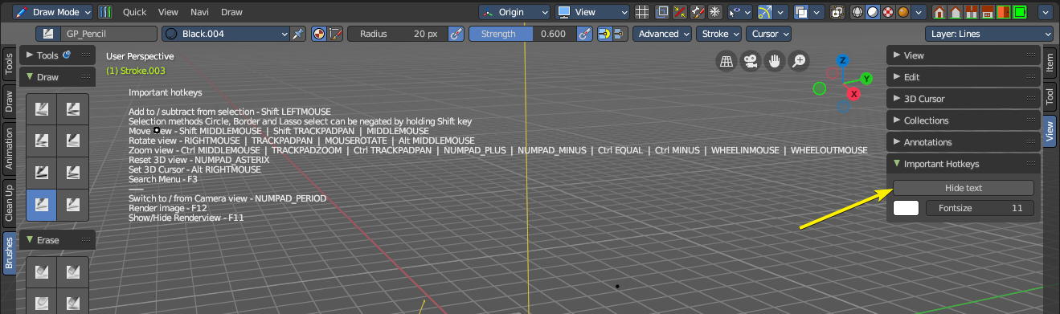

User Interface: Toolbar Settings Bforartists
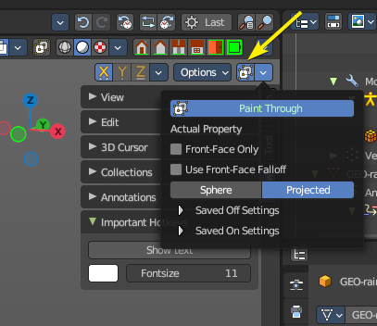
This addon is activated by default. This stores the toolbar settings. Do not turn off.

Utility: X Ray Weight Paint
This addon is optional and deactivated by default. This addon helps automate the process of setting up xray painting for armature weight painting. This helps set up various user settings for a desired user experience.
This addon is thanks to Blender Boi. You can find the repository here: https://github.com/BlenderBoi/XRayWeightPaint-

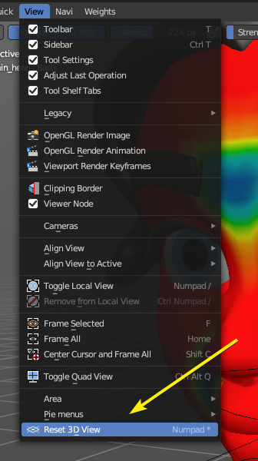
View: 3D View Reset
This addon is activated by default. This adds an operator to the interface to reset the view – both accessible in the 3D View – View header menu entry and the optional header buttons to the top right. You can alternatively use the * key on the Numpad.

